3.7 Module Test (Selenium Test)
Specimen Collection
Tester | Shreya Karki
Date | 24/09/2026
Module | Specimen Collector
Testing Tool | Selenium WebDriver
Web Browser | Firefox

Test Case Summary
Test ID | Web Browser | Test Result | Comment
Test 07– Specimen Registration | Mozilla Firefox | PASS | To check specimen registration, code-based automated tests were run in CMD (Command Prompt) using Selenium WebDriver and Python Manager. These tests included entering specimen information, choosing necessary fields, looking up patients, and submitting the registration form.
TEST 08– Specimen Collection | Mozilla Firefox | PASS | The Specimen Collection module, including specimen search, specimen information display, collection details entry, collection status selection, and needed field validation, was verified using Selenium WebDriver with Python Manager.
TEST 09- Specimen Tracking | Mozilla Firefox | PASS | The Specimen Tracking module was verified using Selenium WebDriver with Python Manager, which included looking for a valid specimen ID, displaying specimen details, and reviewing specimen tracking history.
TEST 10- Specimen Receipt | Mozilla Firefox | PASS | The Specimen Receipt module, which includes specimen search, displaying specimen details, receiving information, laboratory location, receipt status, notes, and form validation, was verified using Selenium WebDriver and Python Manager.
TEST 11- Specimen Assessment | Mozilla Firefox | PASS | The Specimen Assessment module, comprising specimen search, assessment checklist, accepting or rejecting a specimen, choosing a rejection reason, adding comments, and resetting the form, was verified using Selenium WebDriver and Python Manager.
TEST 12- Specimen Recollection | Mozilla Firefox | PASS | Performed Validation of the Specimen Recollection module in the app using Selenium WebDriver and Python Manager: Load recollection requests, display request records, view recollection details, open/close details modal, use registration function for a recollected specimen.

Specimen Registration

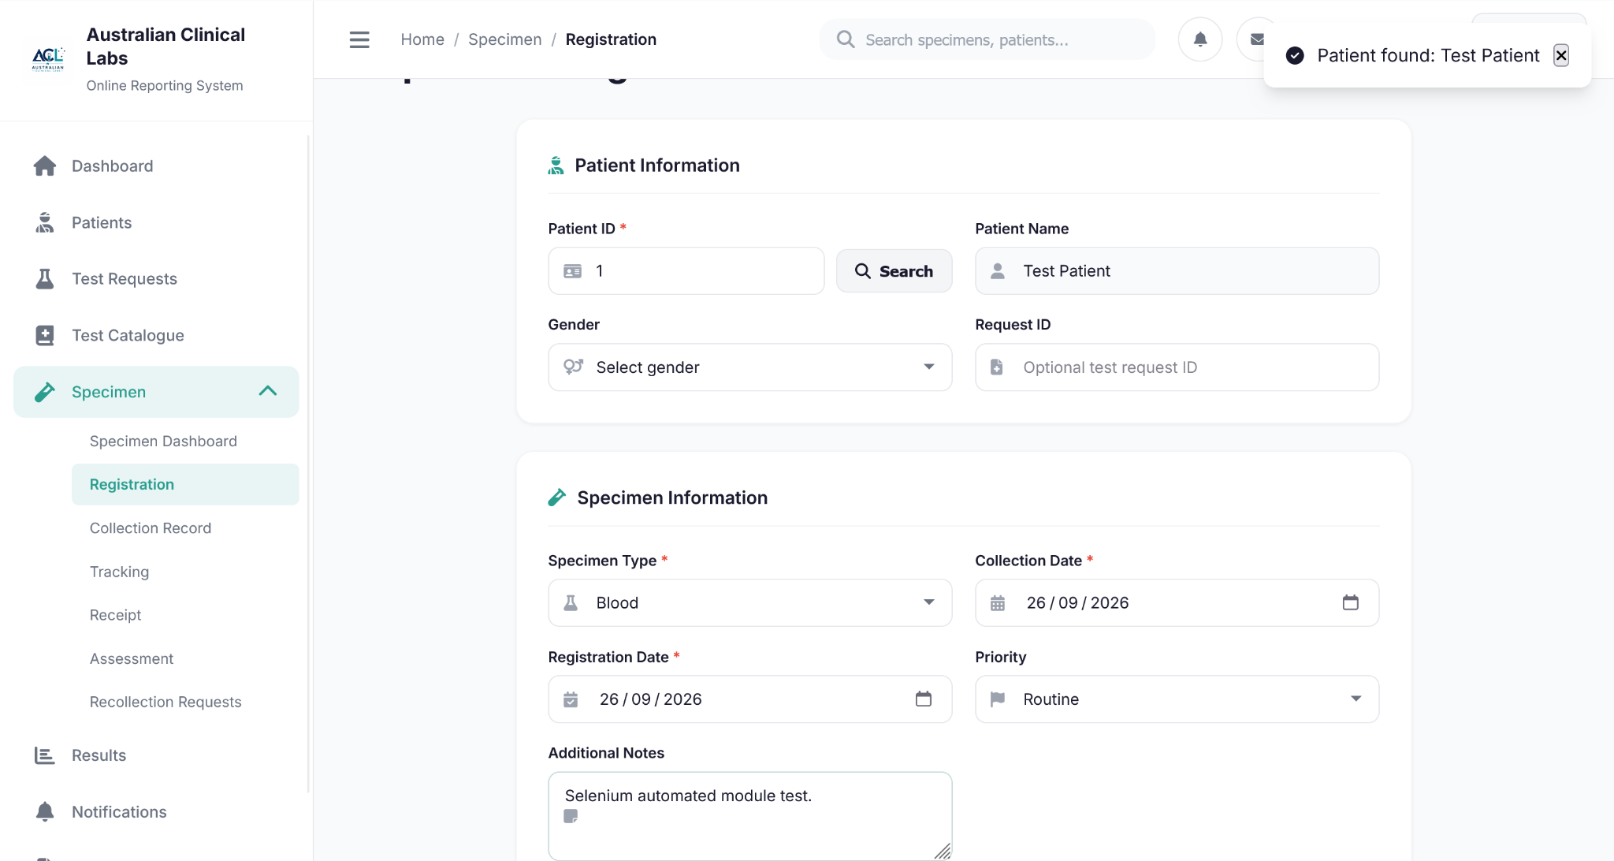
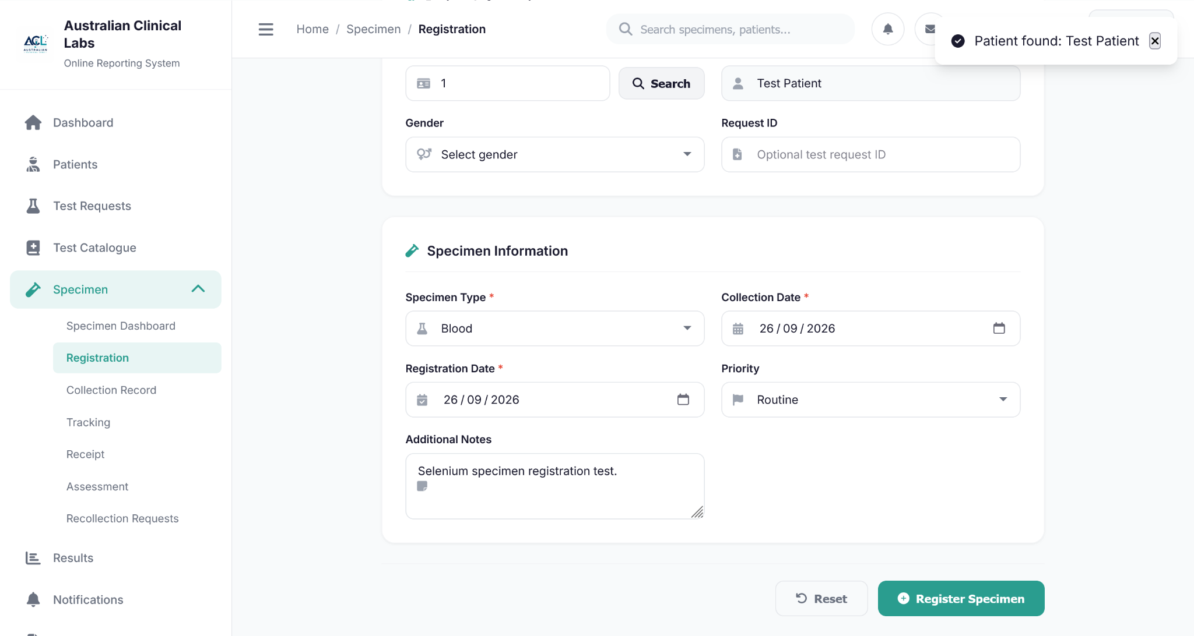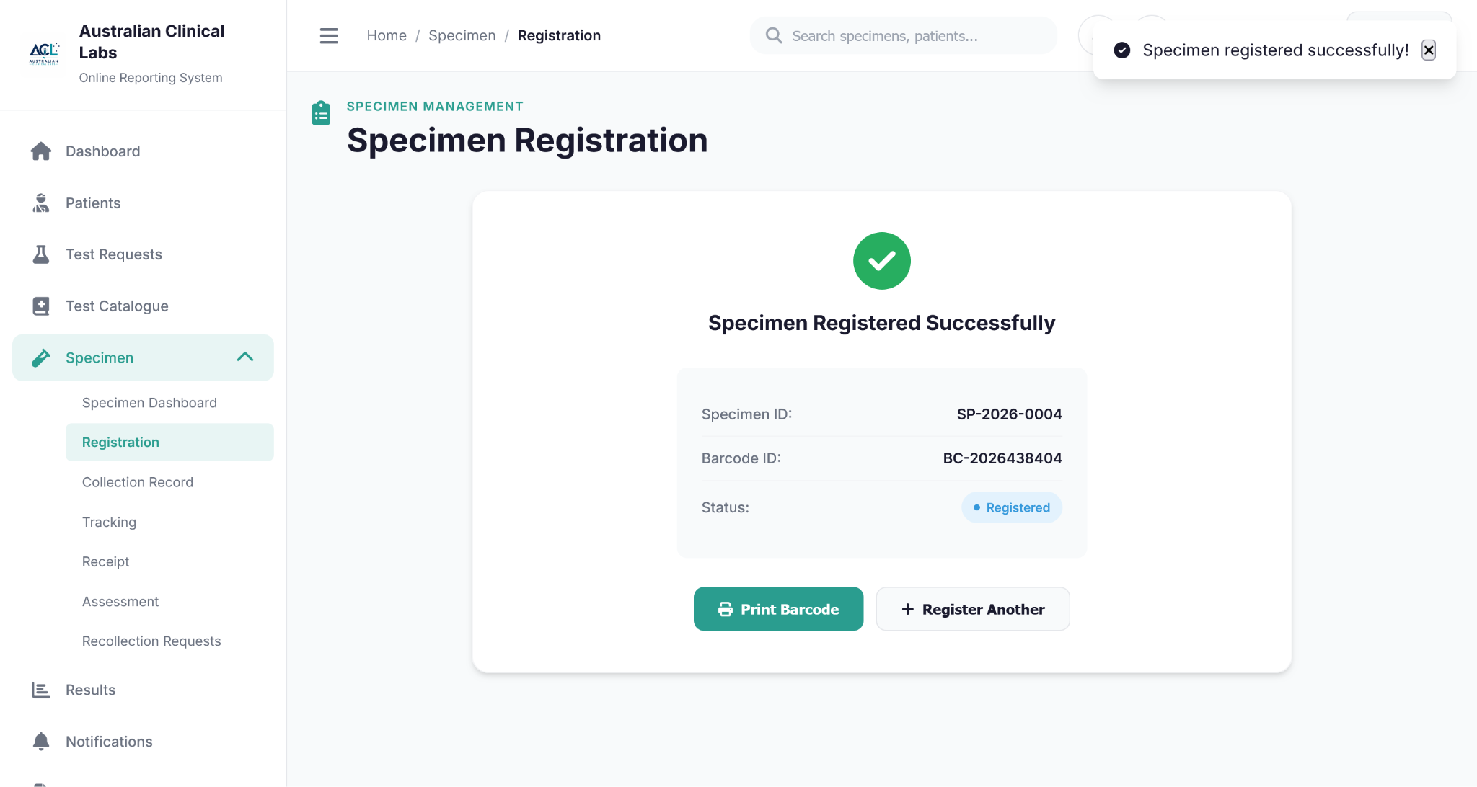

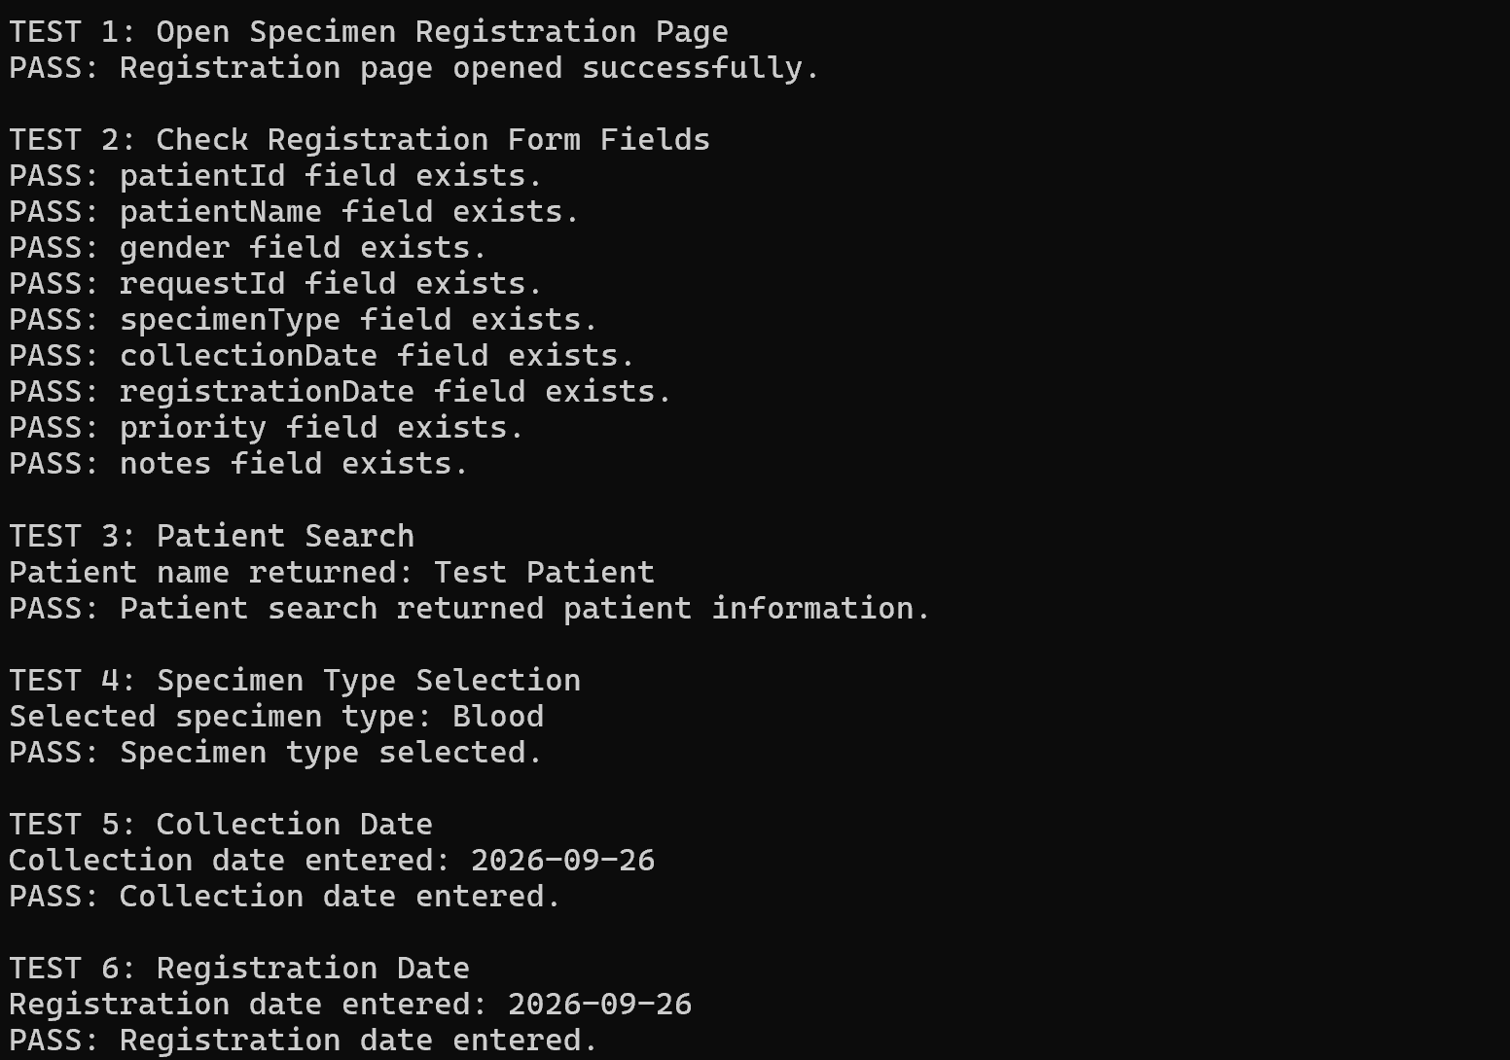

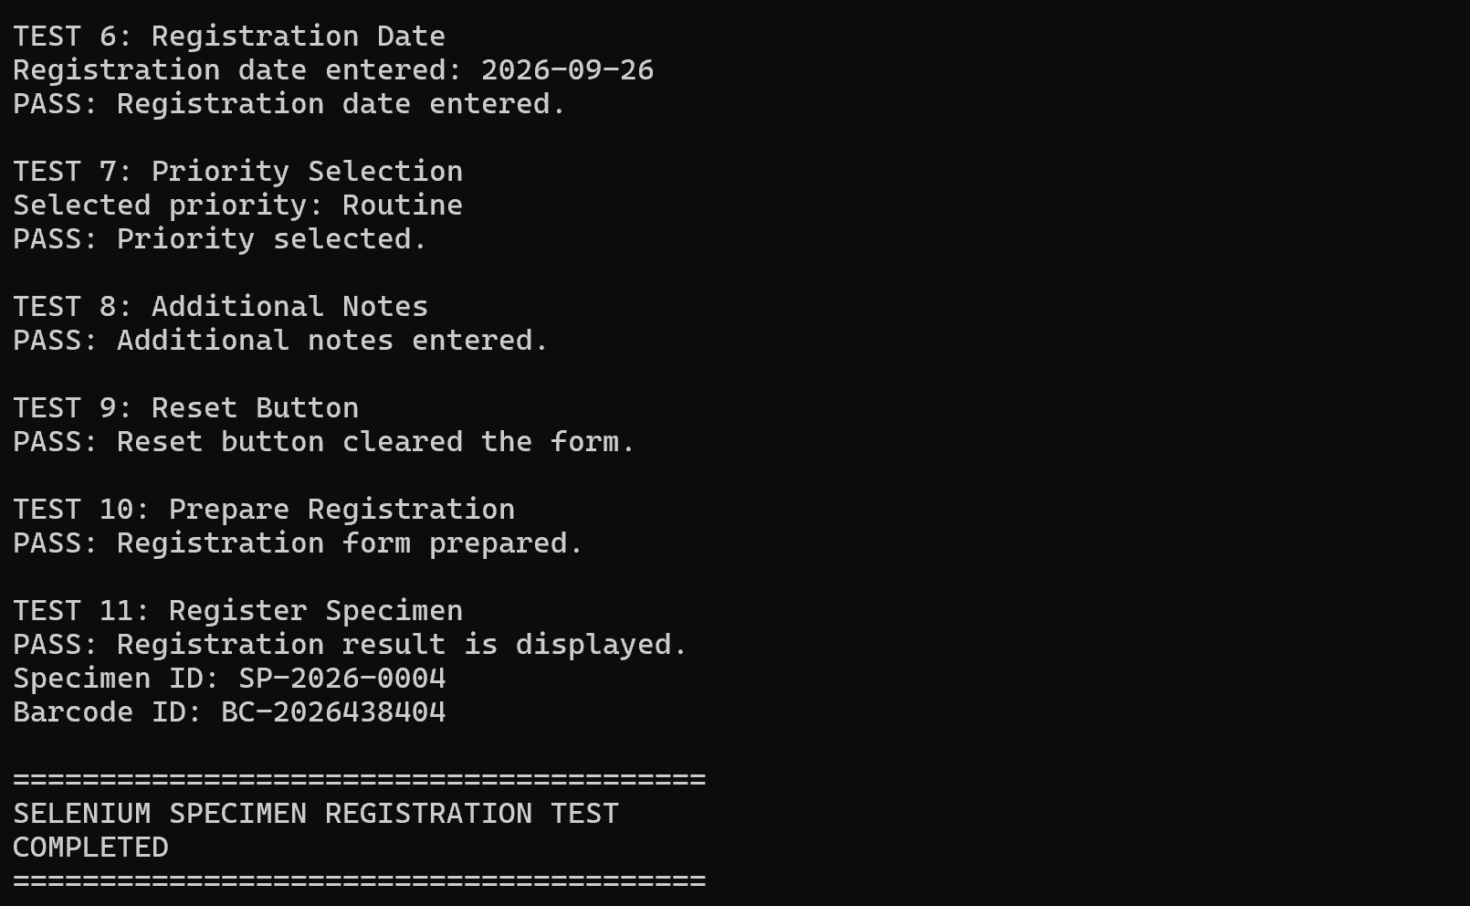
Figure 3.7 – Selenium CMD execution result – PASS

Specimen Collection

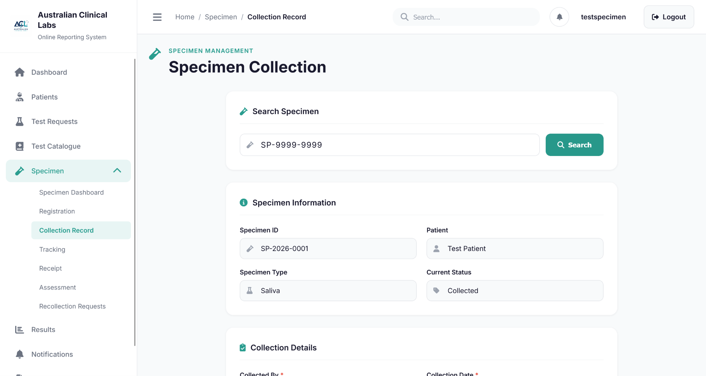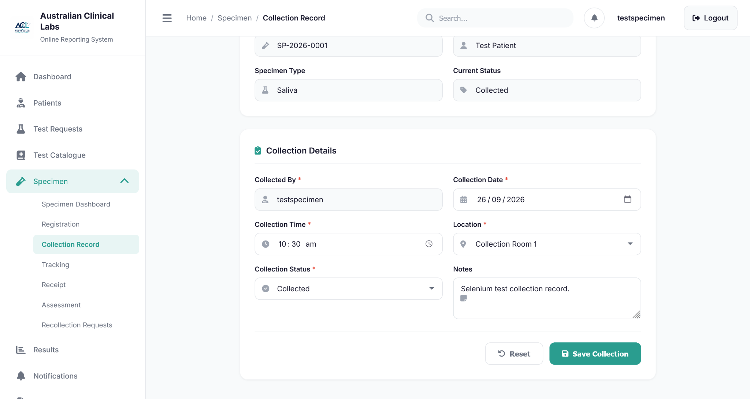
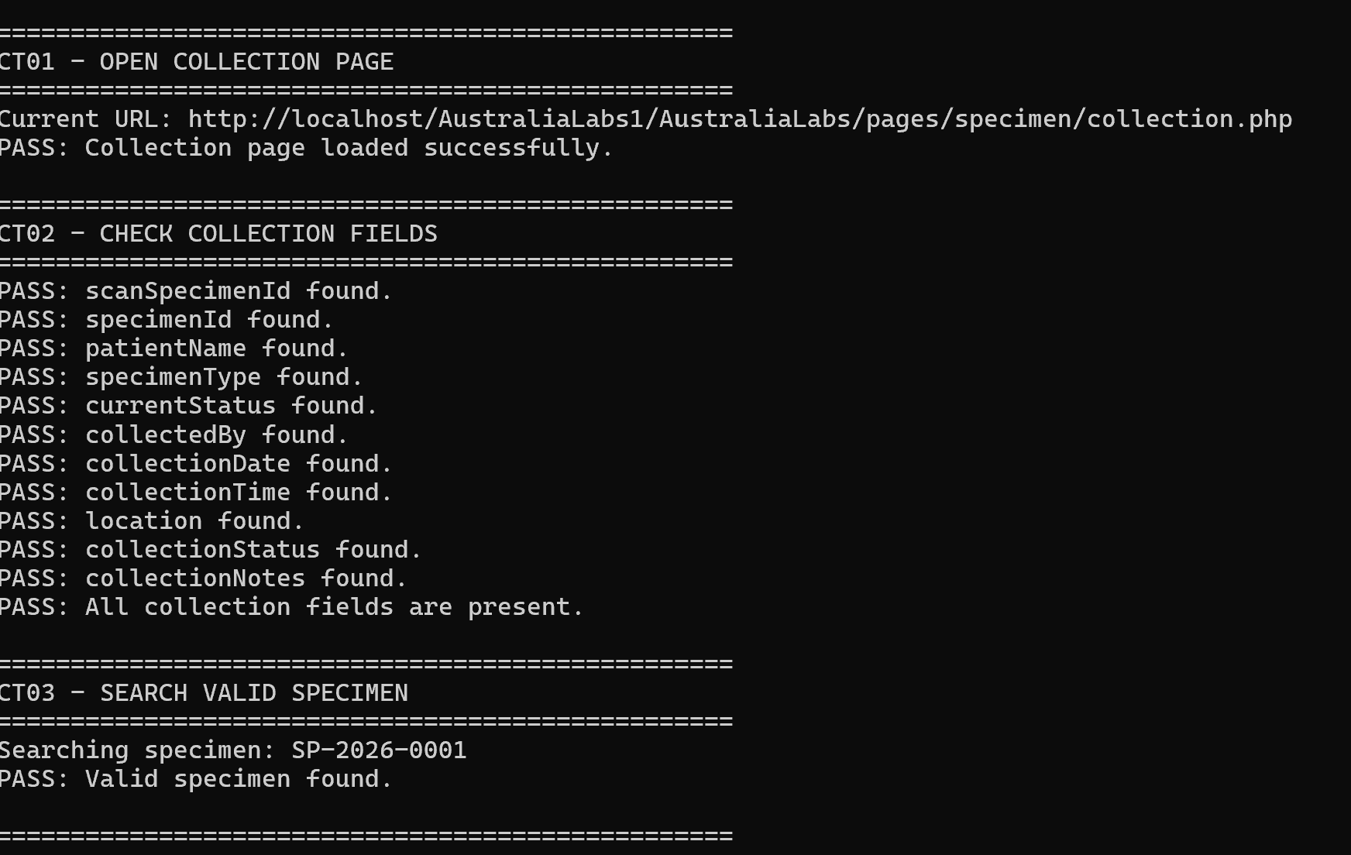
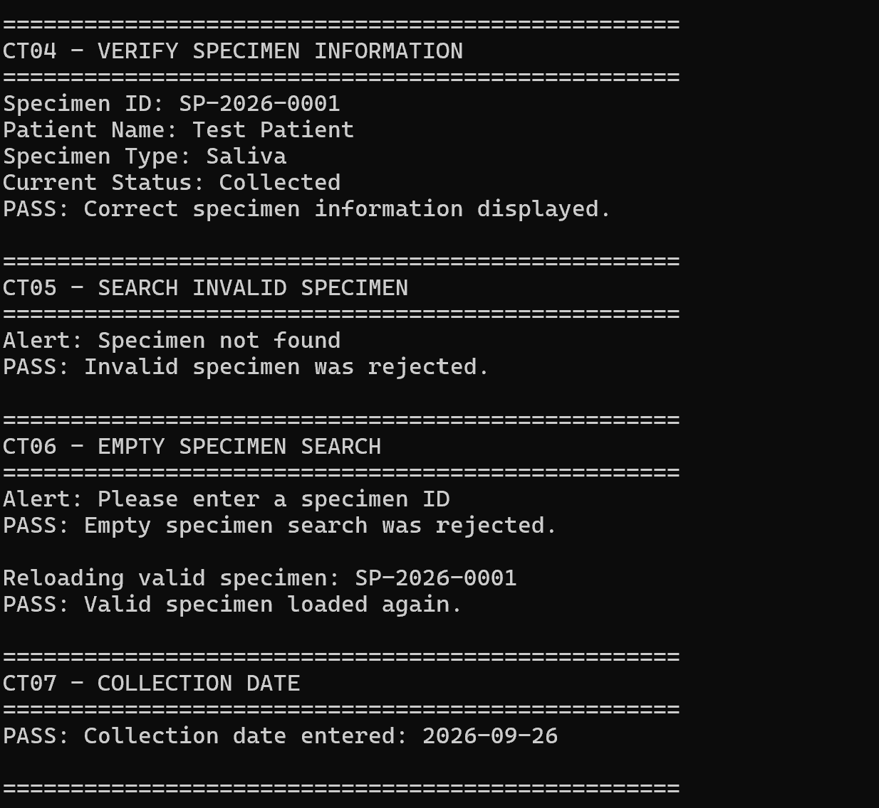
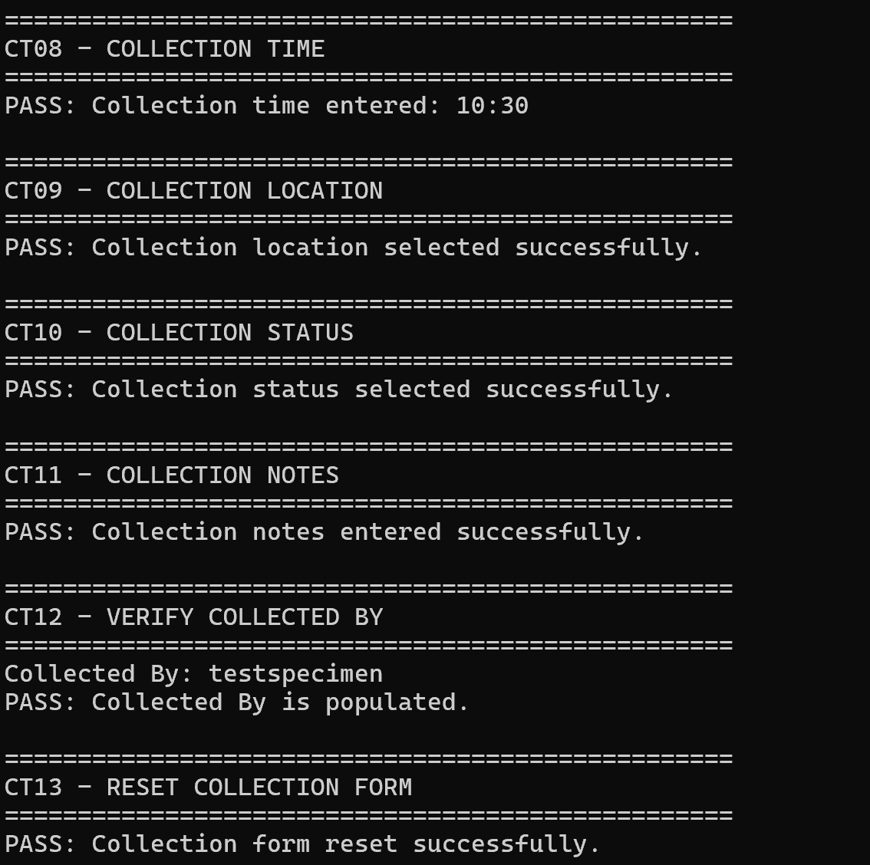
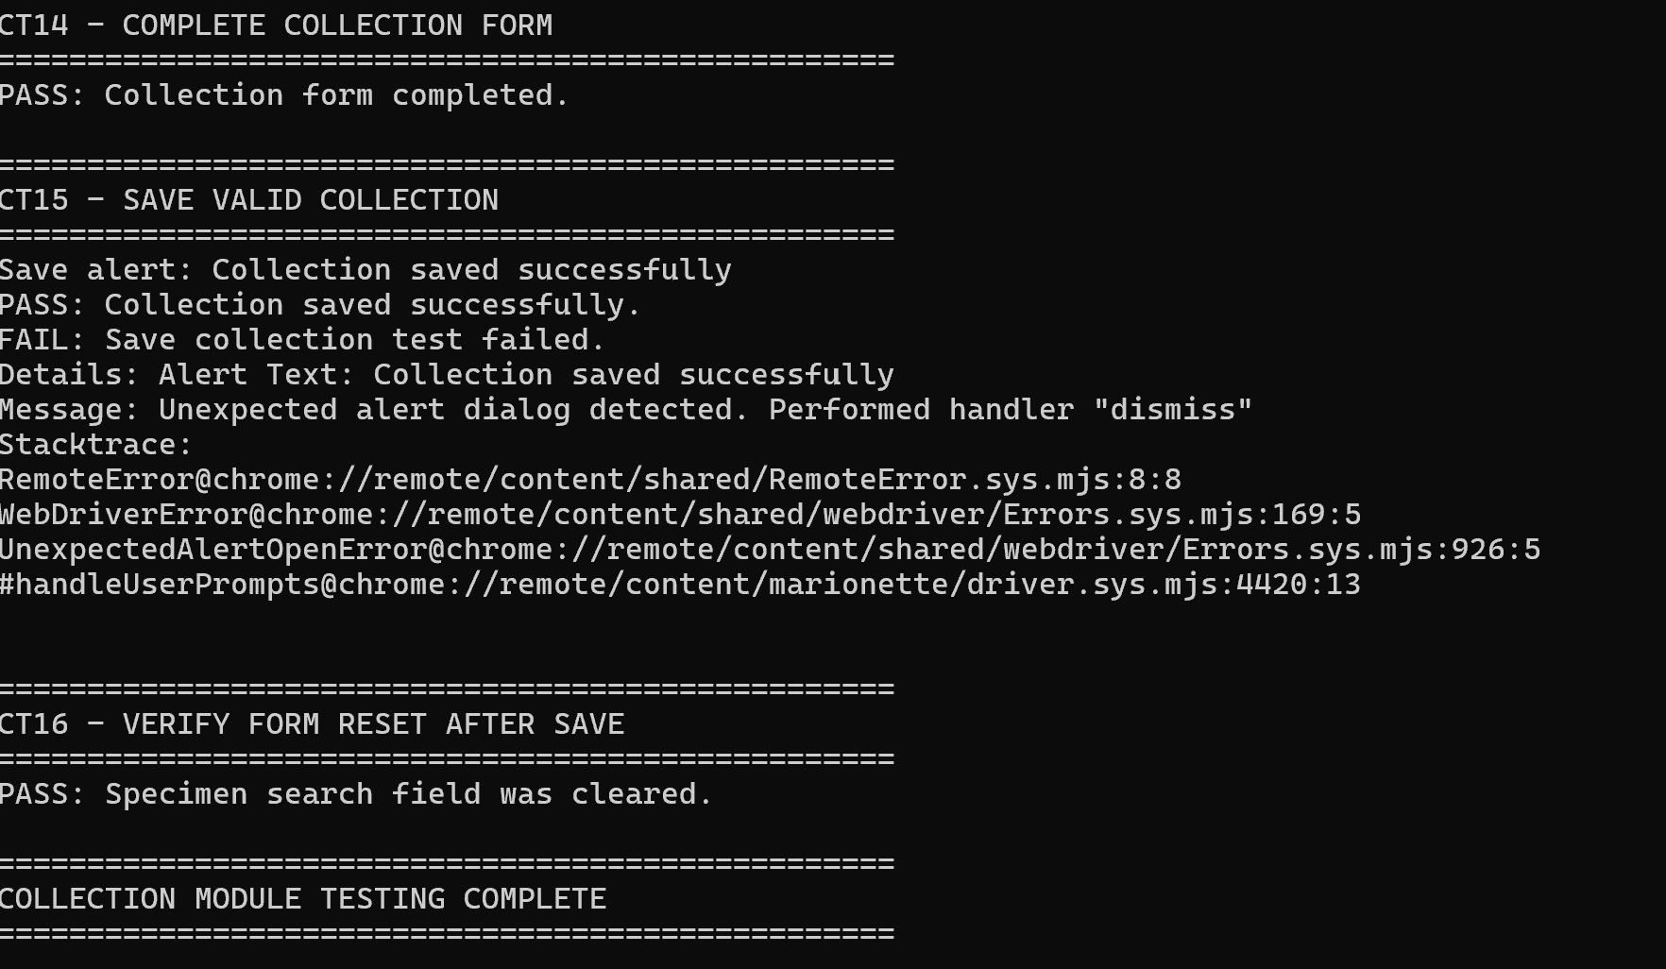
Figure 3.7 – Selenium CMD execution result – PASS

Specimen Tracking
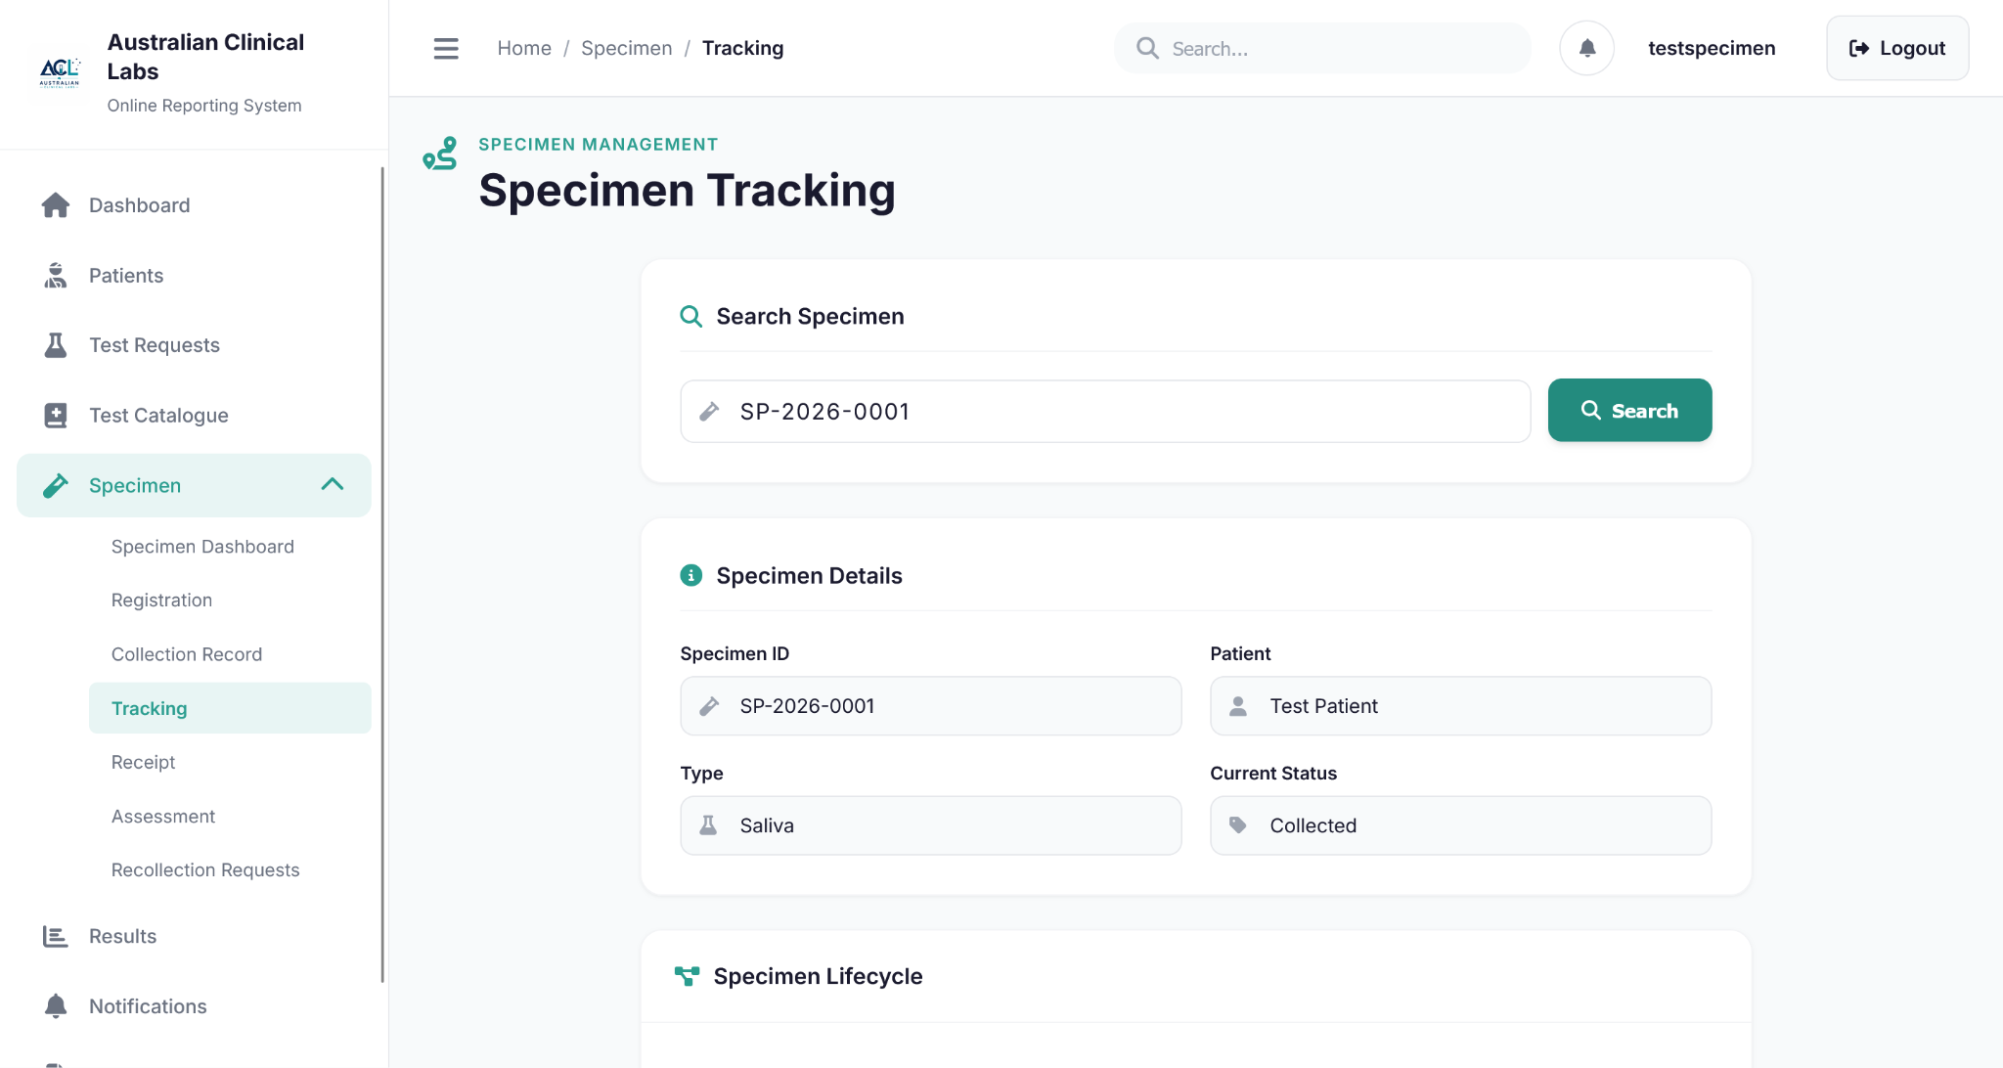
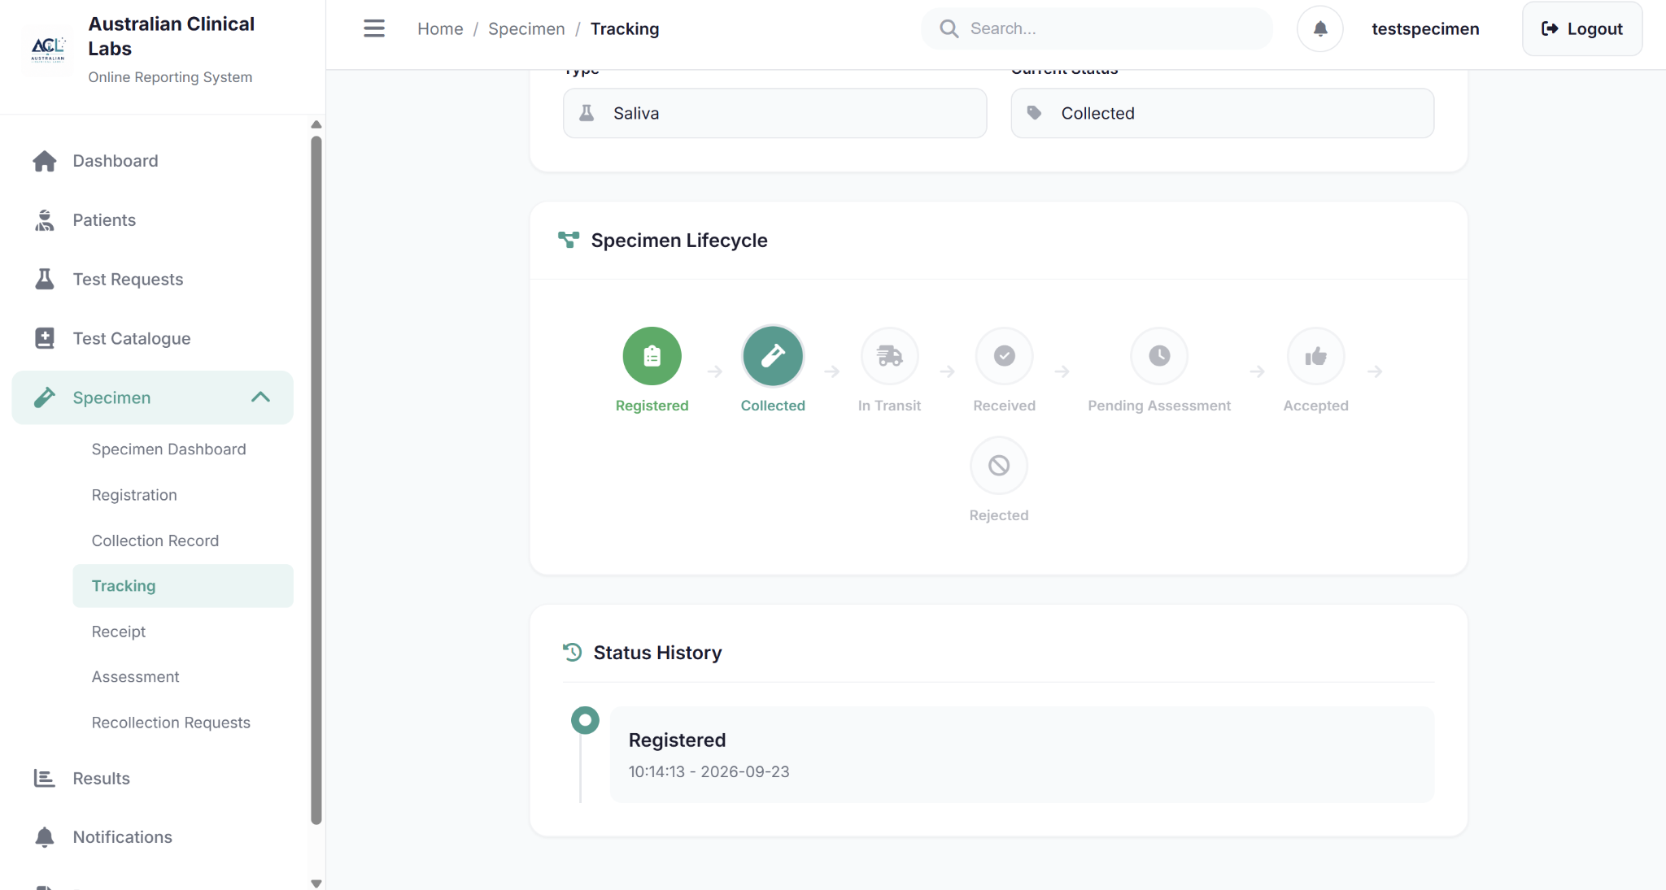

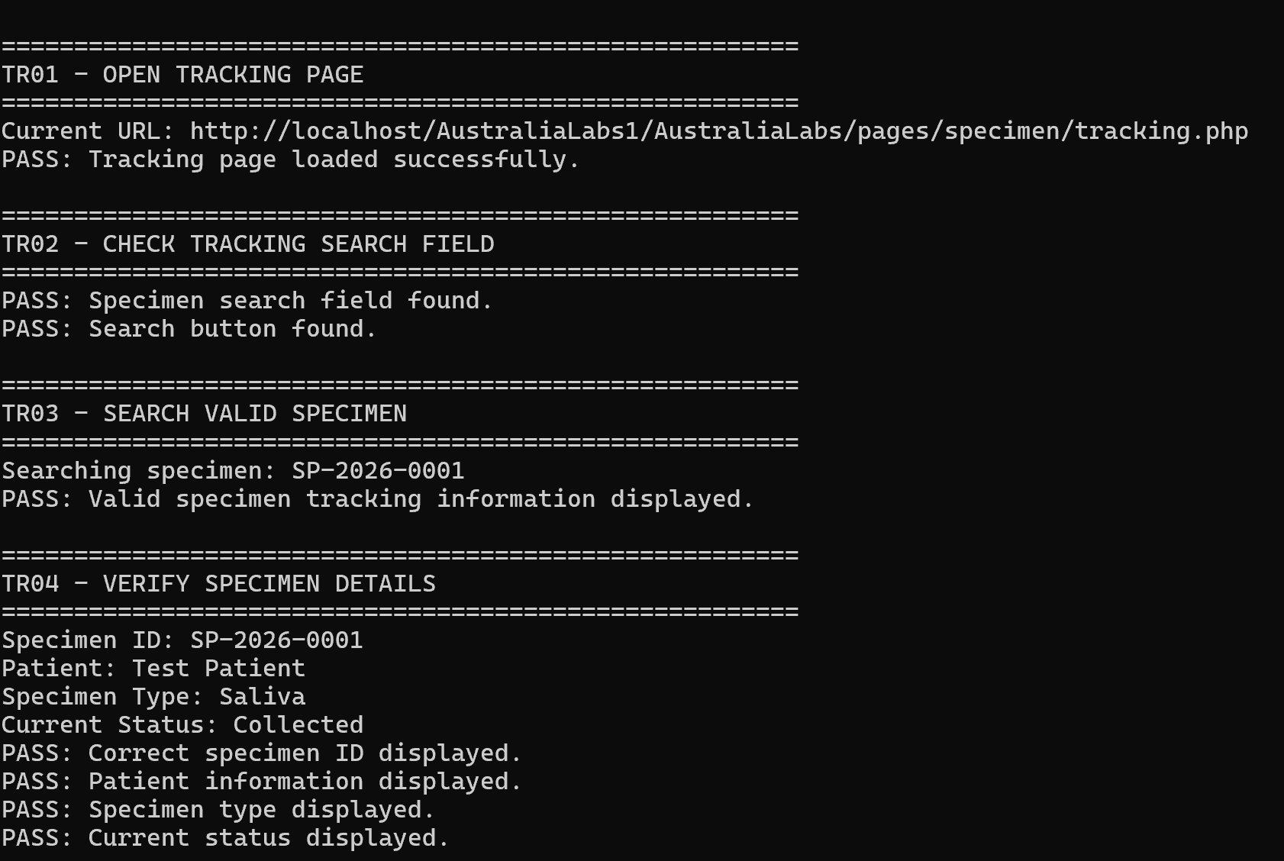
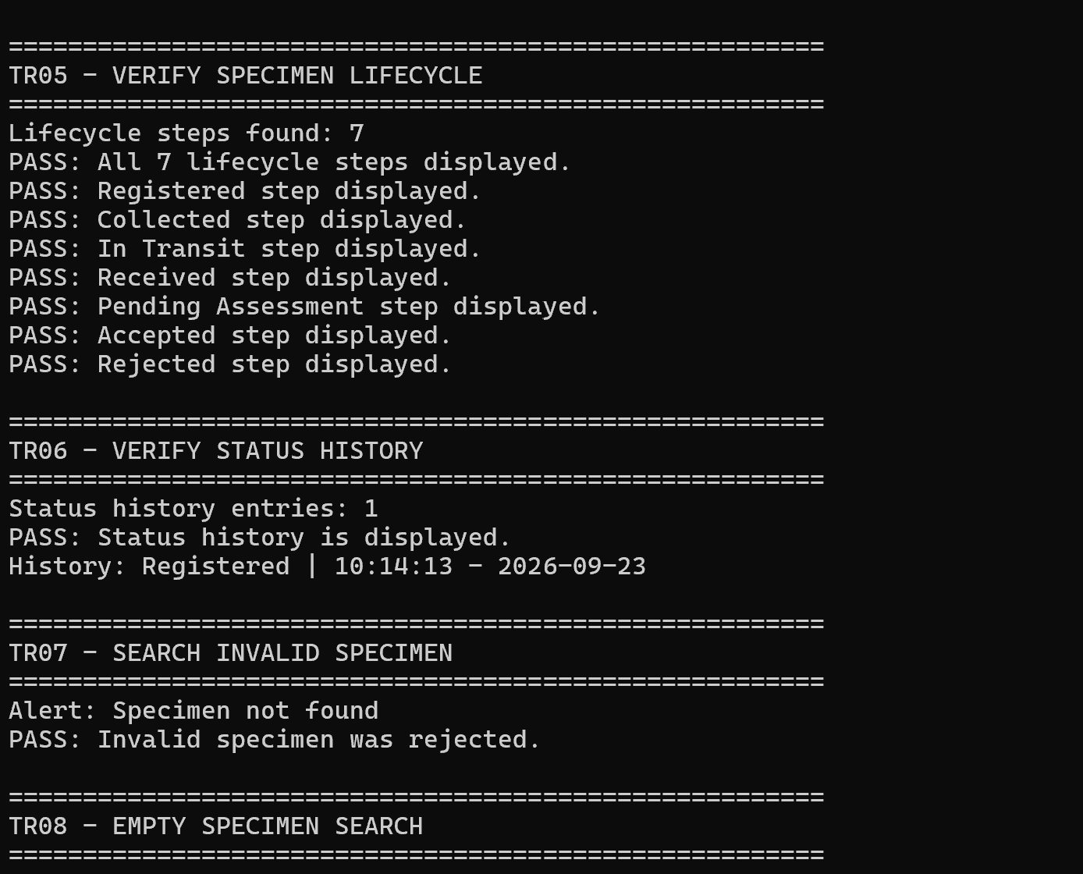
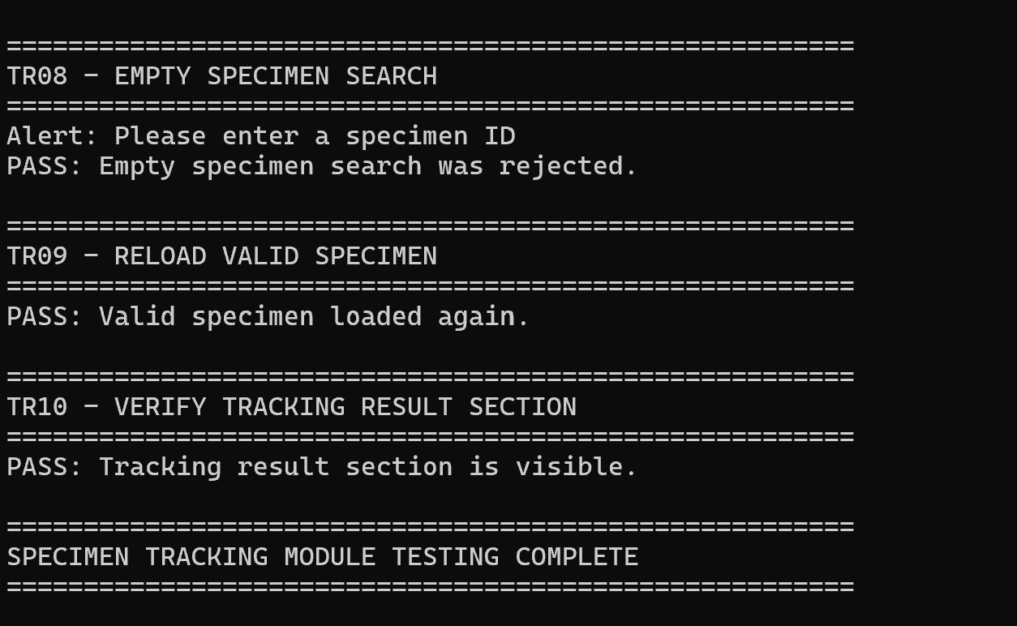
Figure 3.7– Selenium CMD execution result – PASS

Specimen Assessment

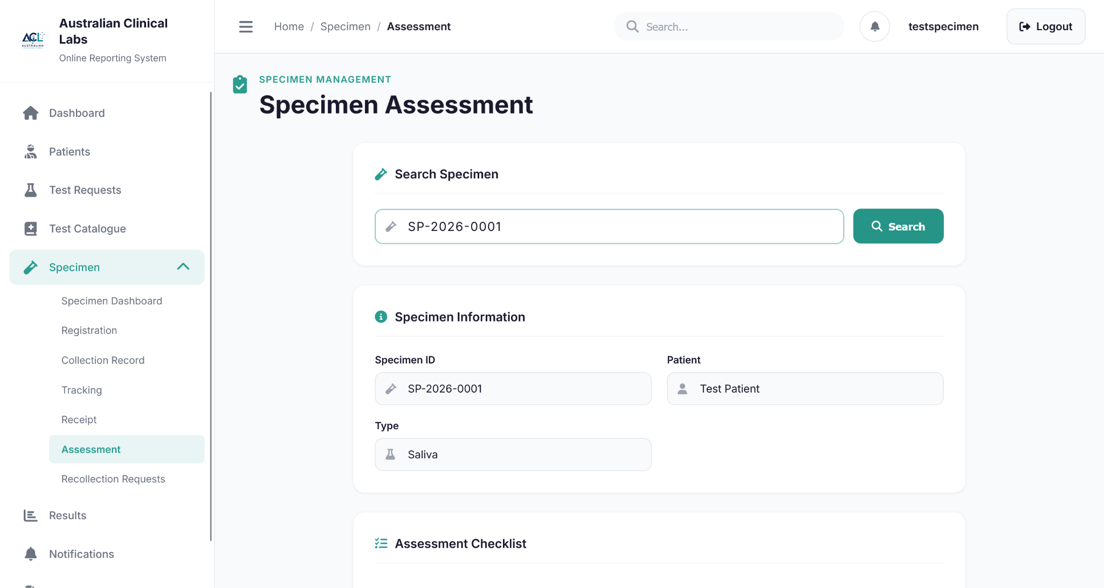
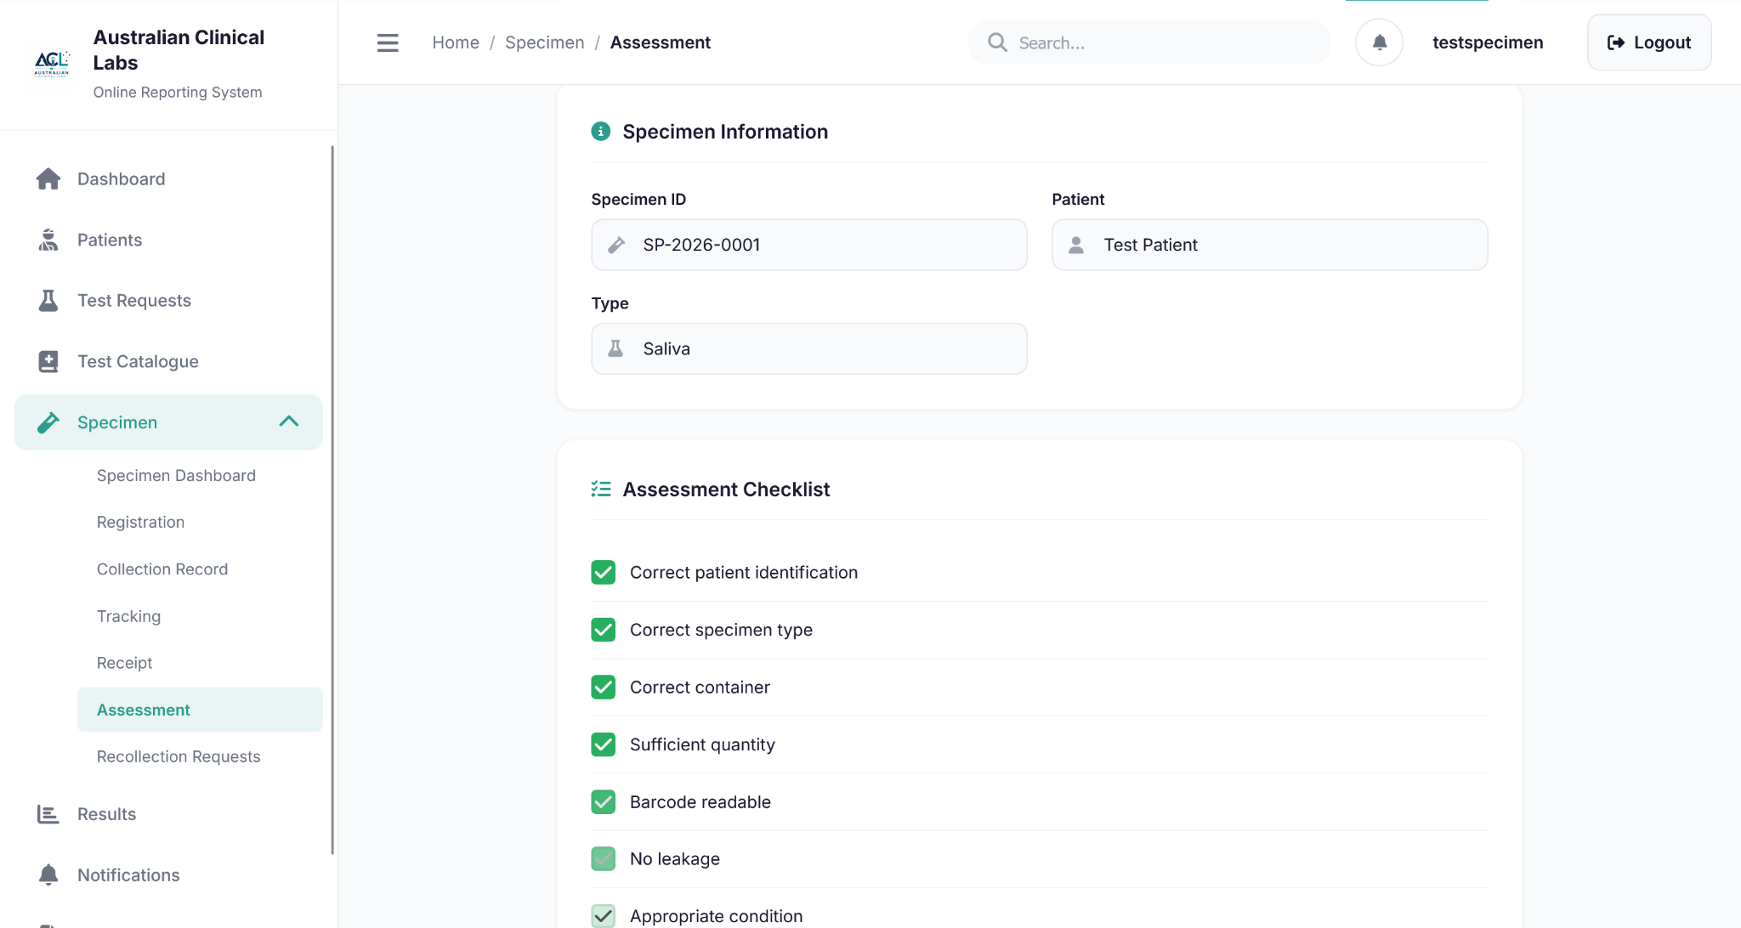
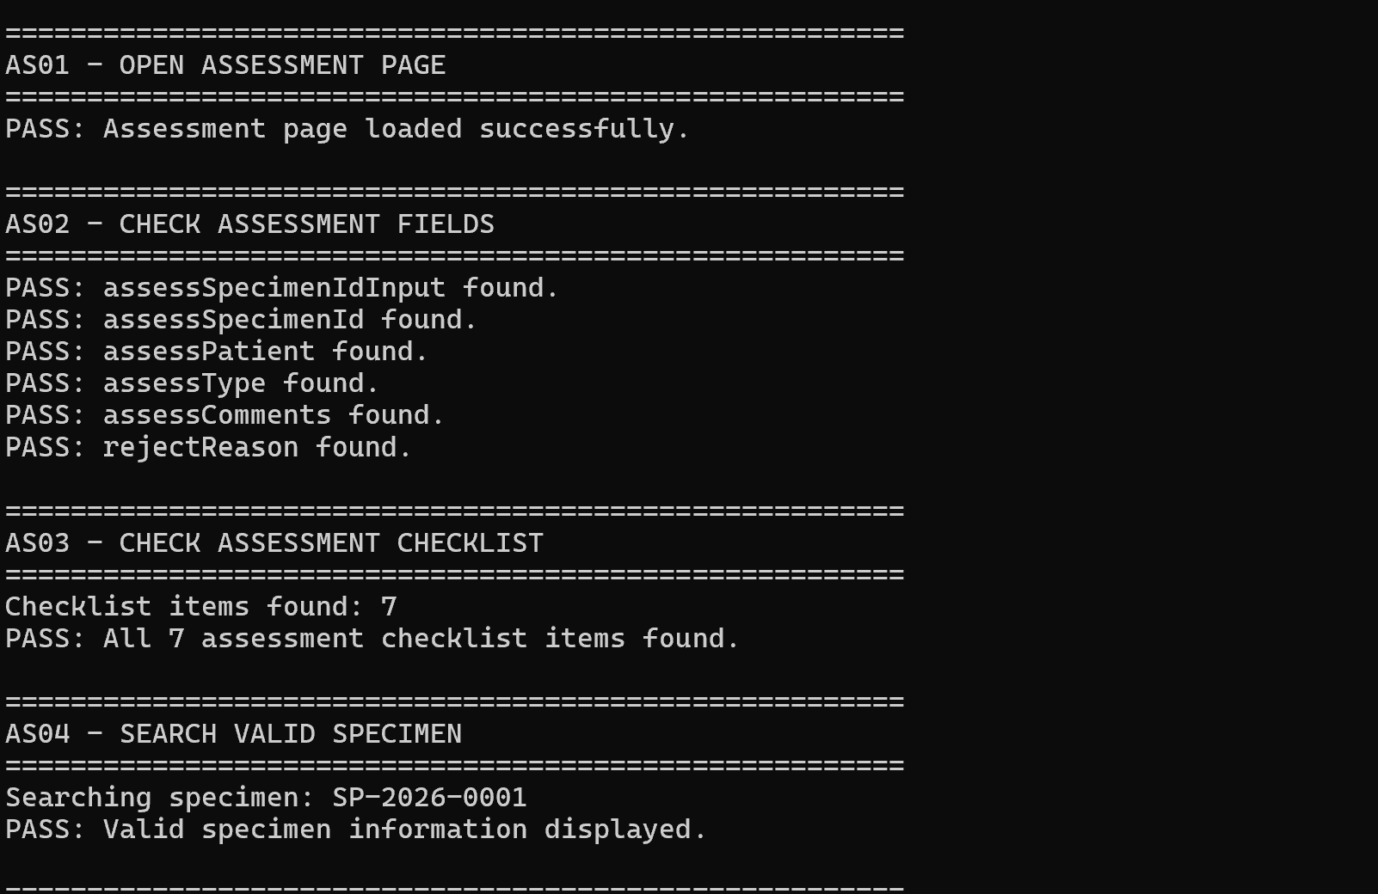
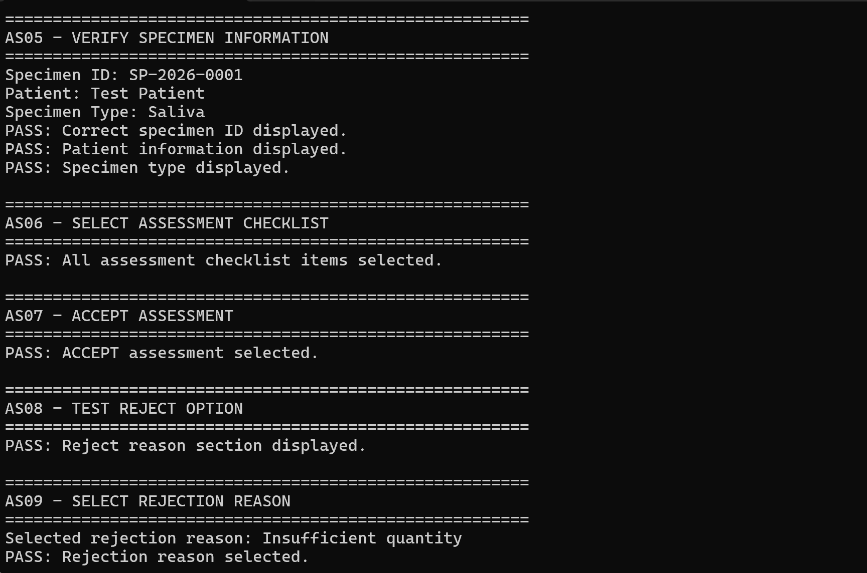
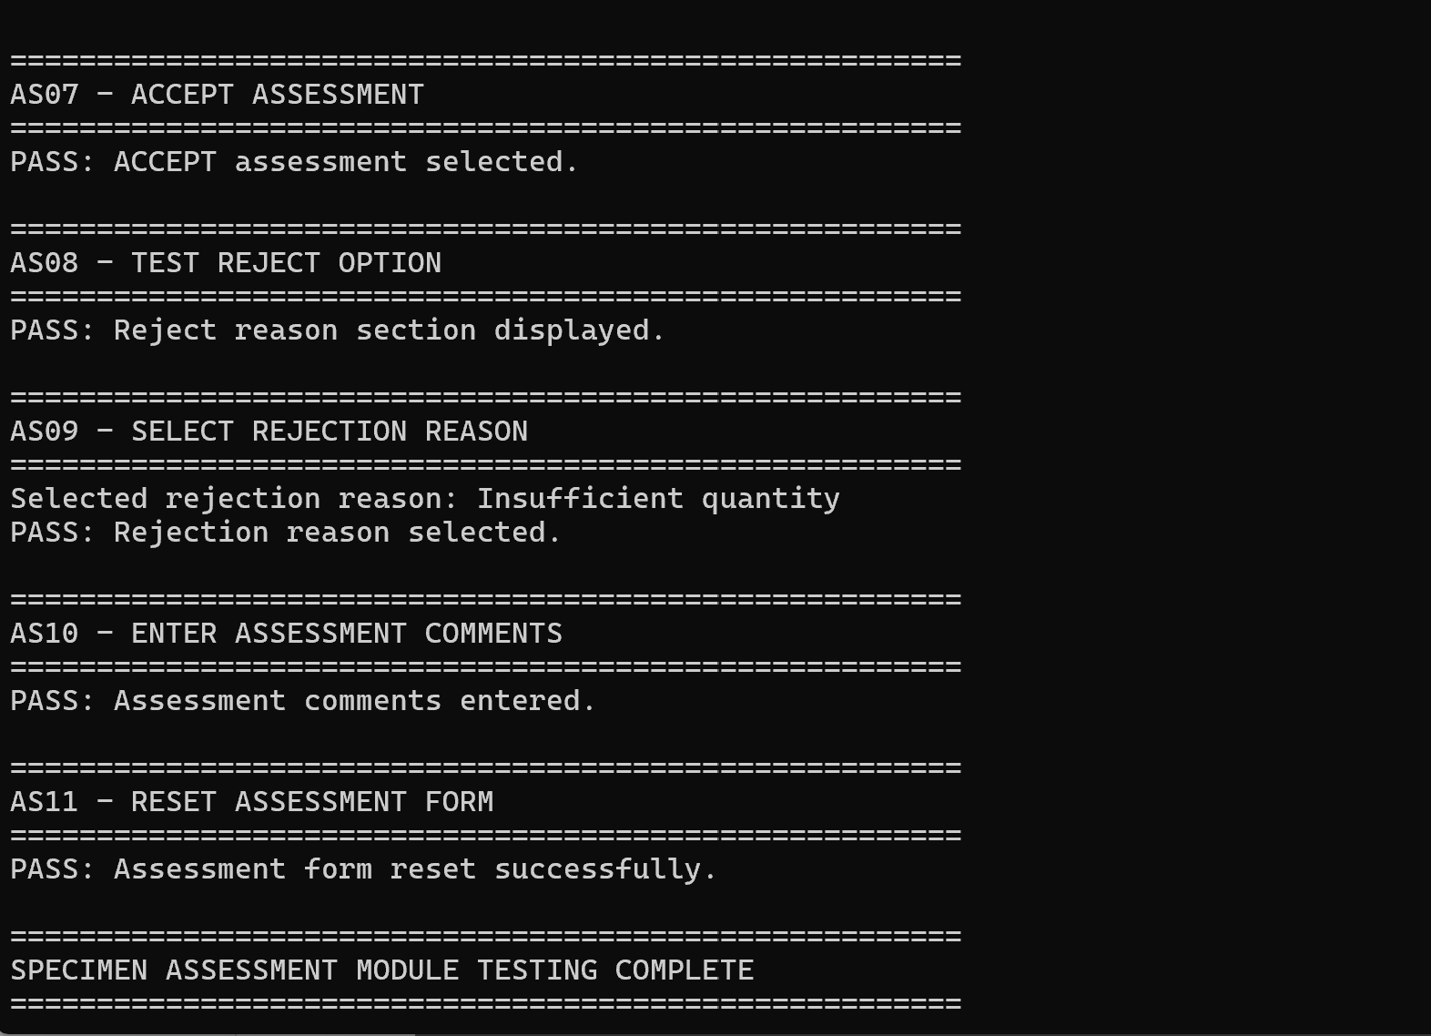
Figure 3.7– Selenium CMD execution result – PASS

Specimen Receipt
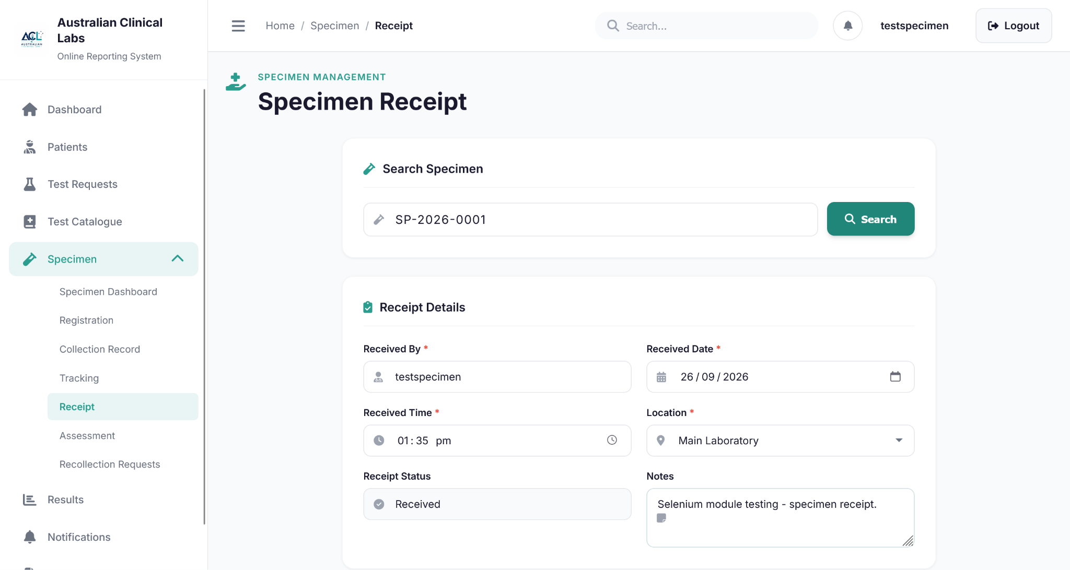
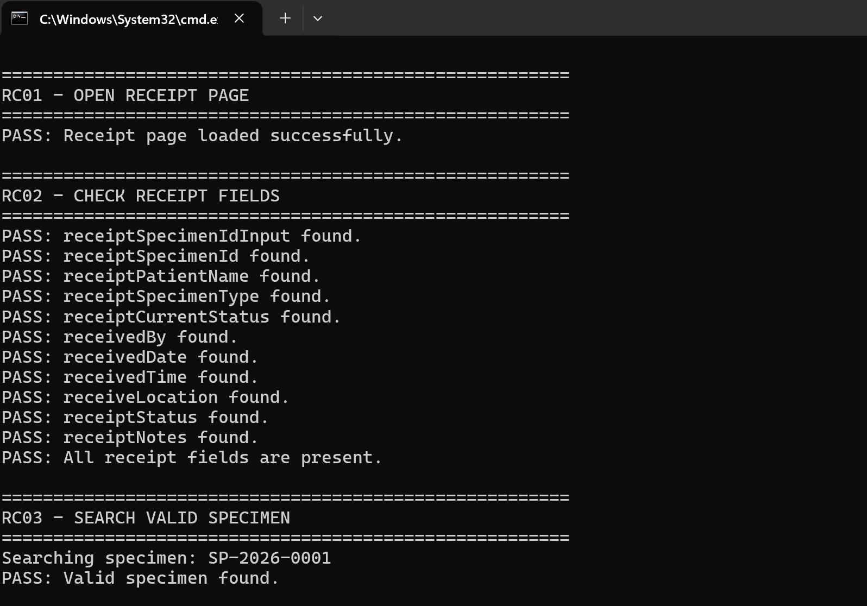
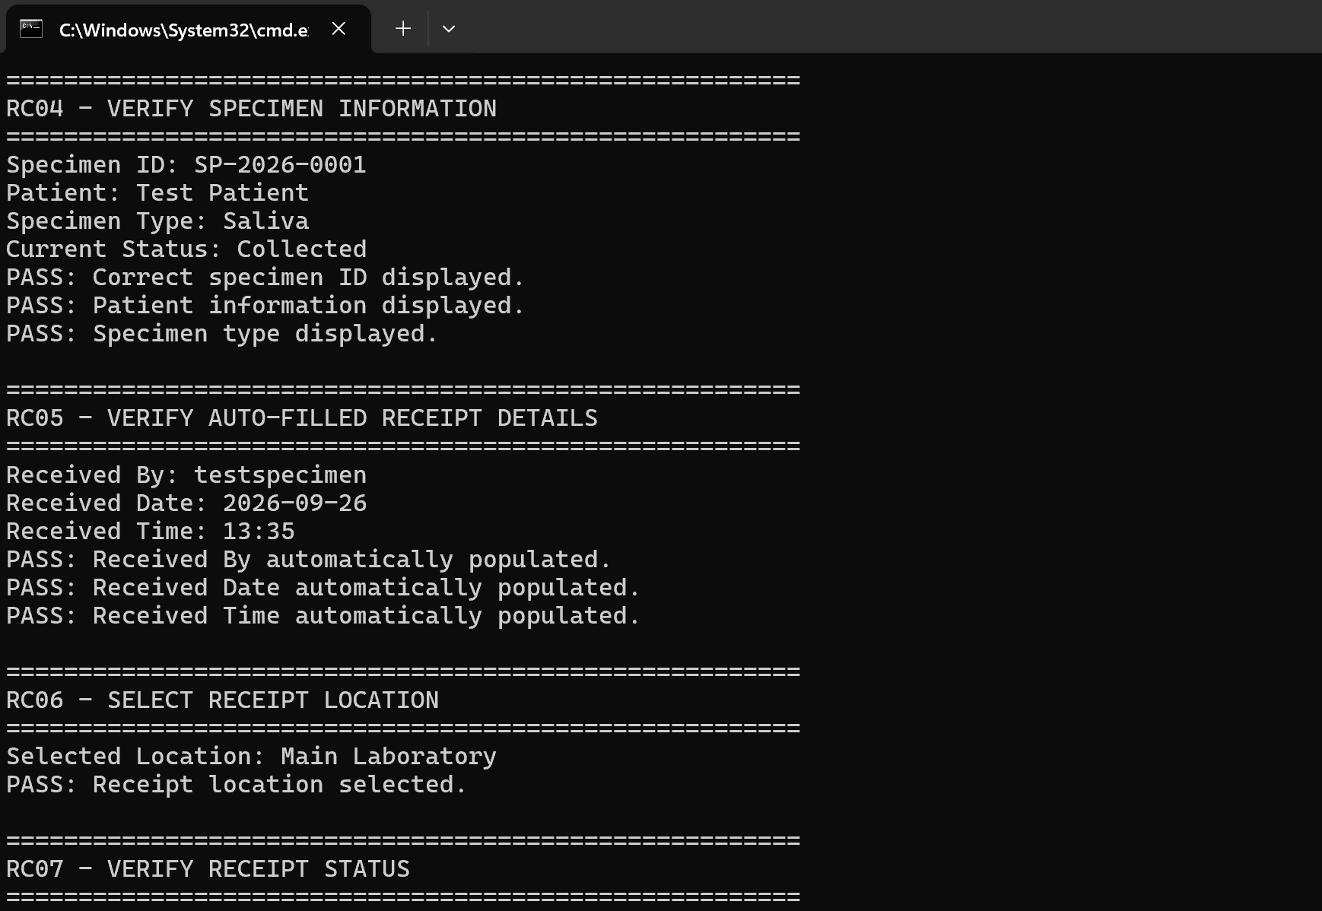
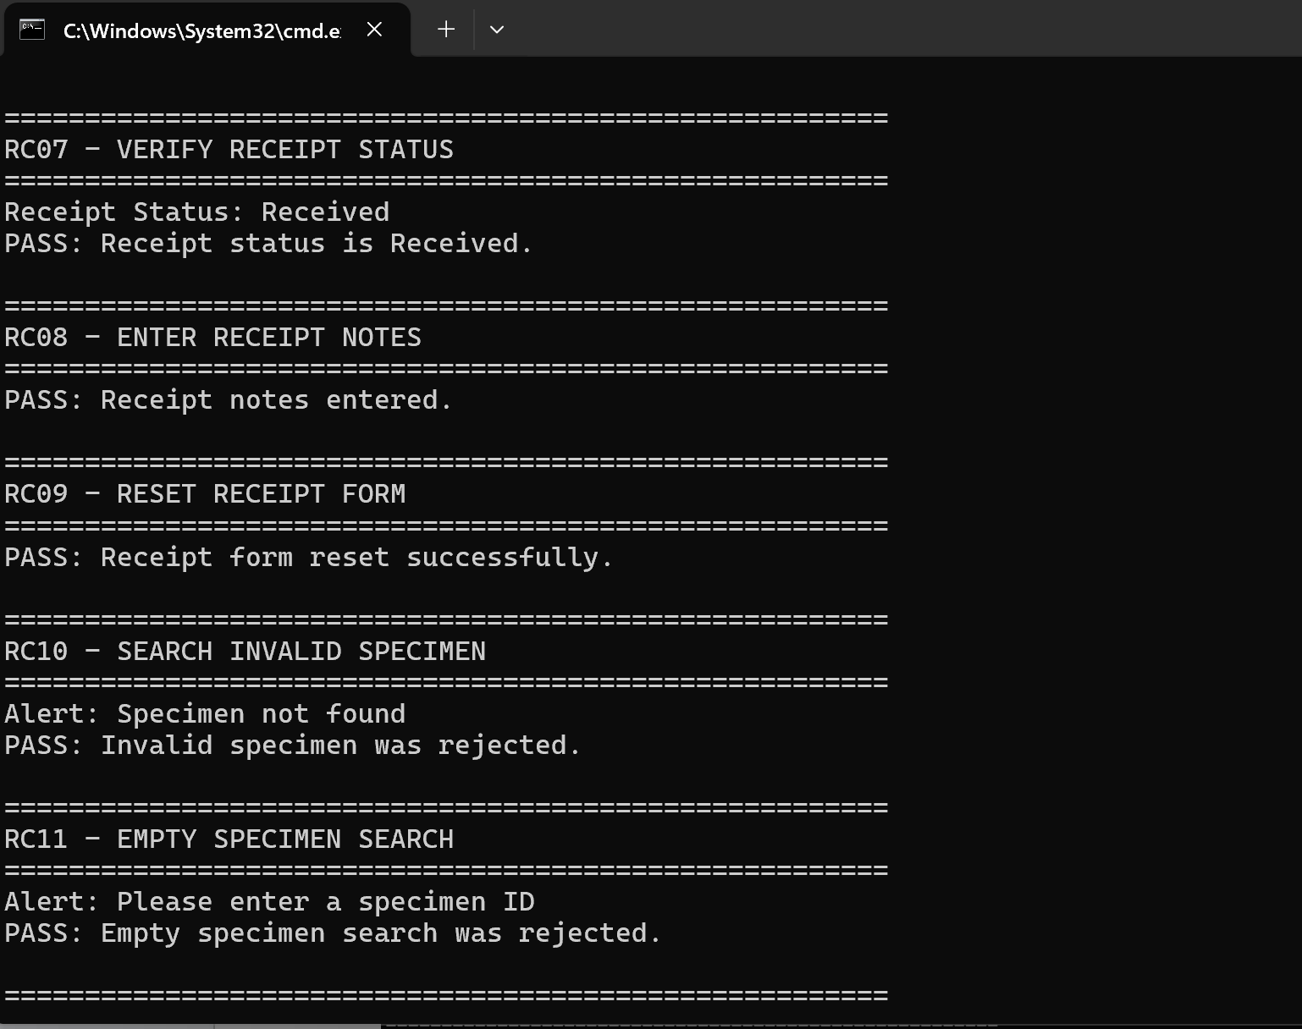
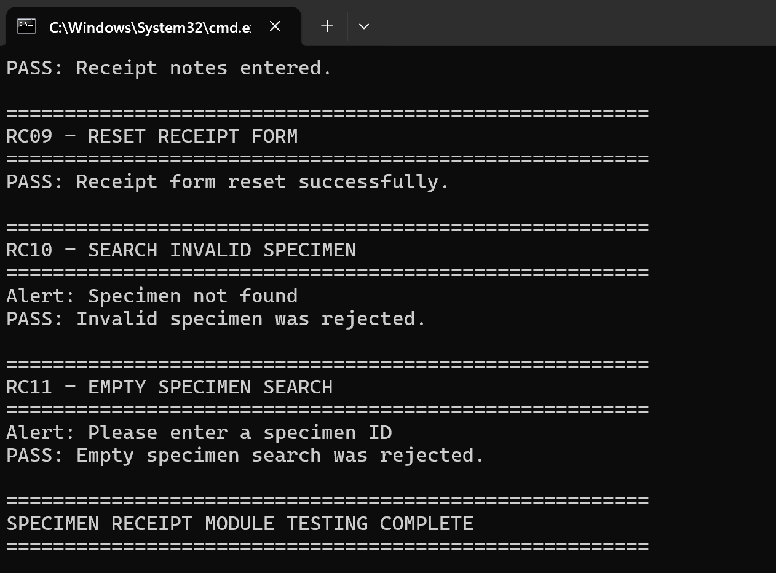
Figure 3.7– Selenium CMD execution result – PASS

Recollection request
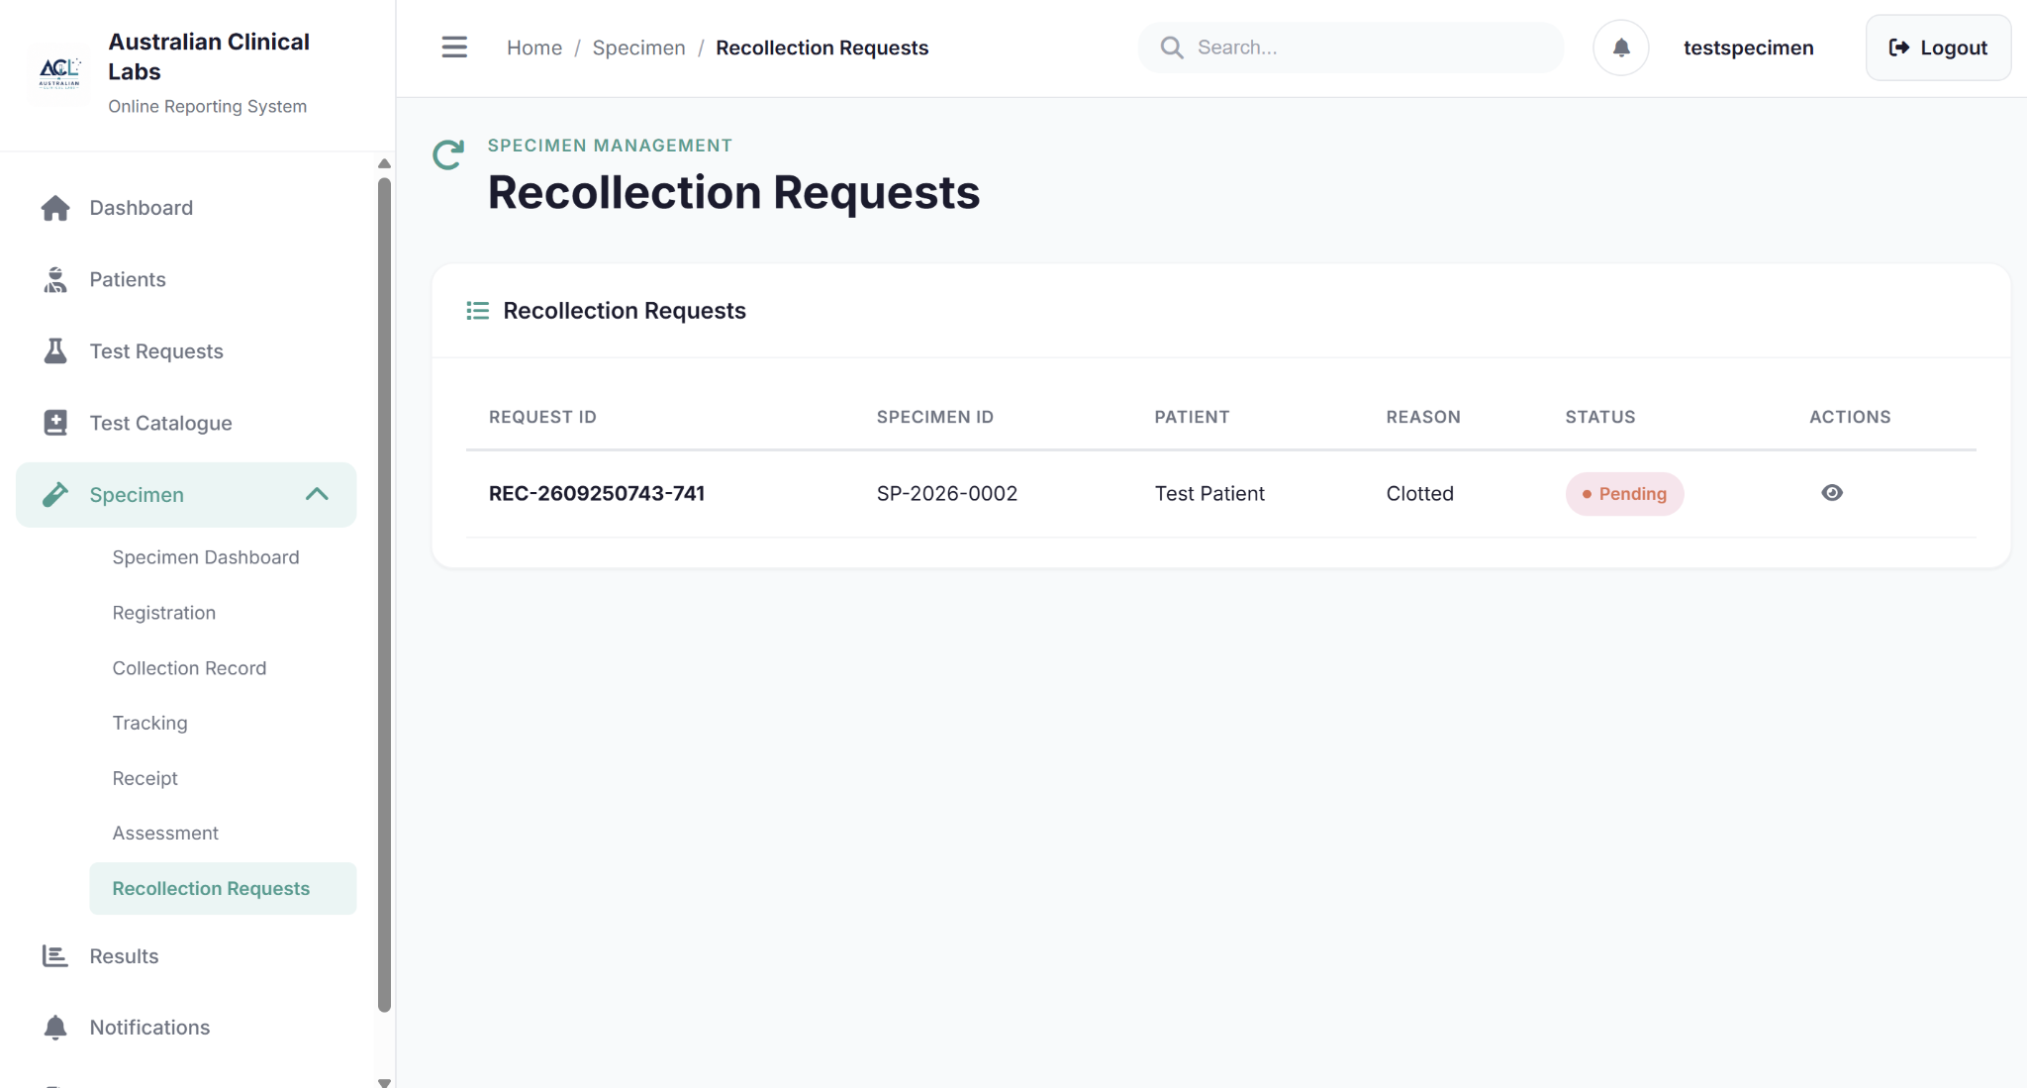
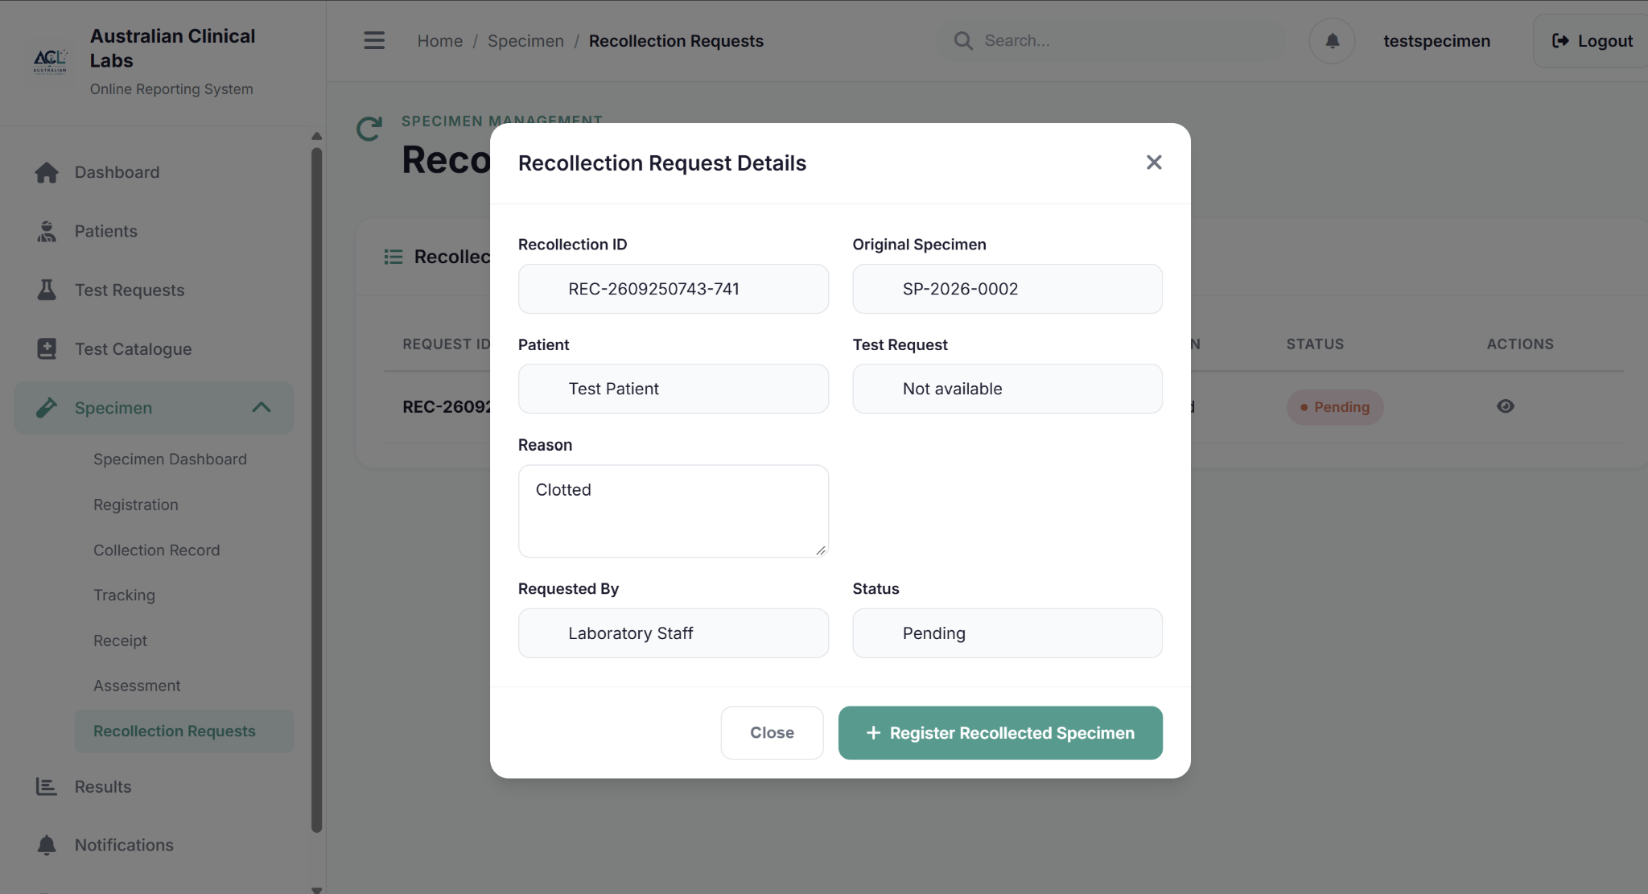
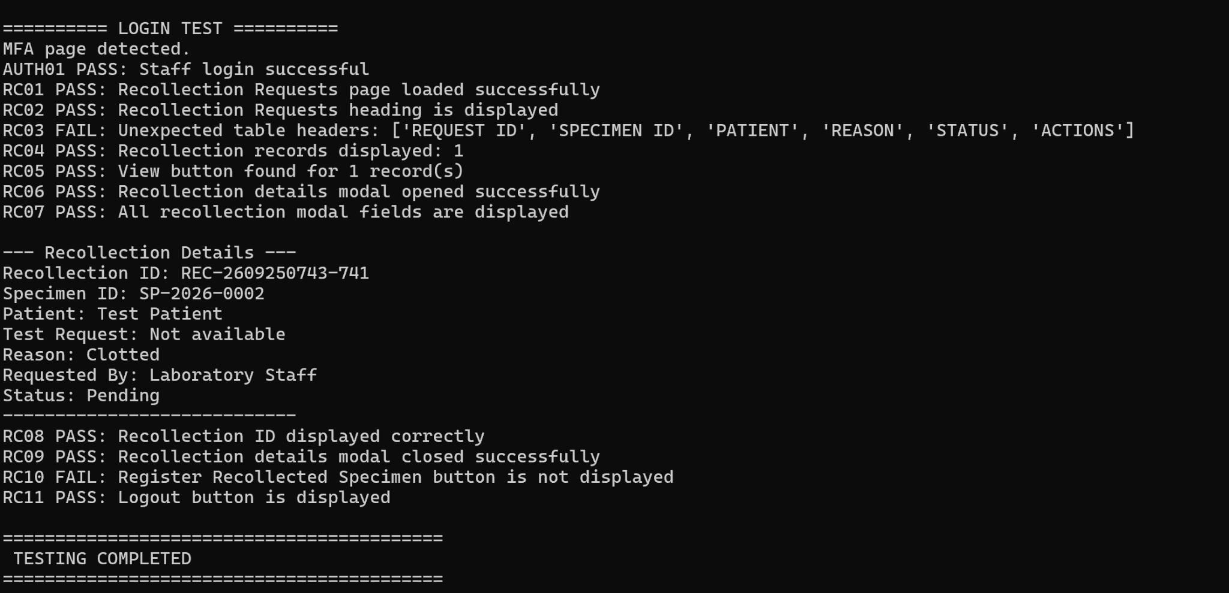
Figure 3.7– Selenium CMD execution result – PASS

